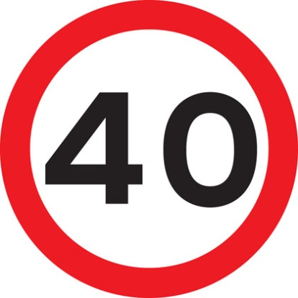 | [ ] Maximum age of driver’s allowed to use this road  [ ] The maximum size of car you are allowed to drive on this road  [ ] Maximum speed limit
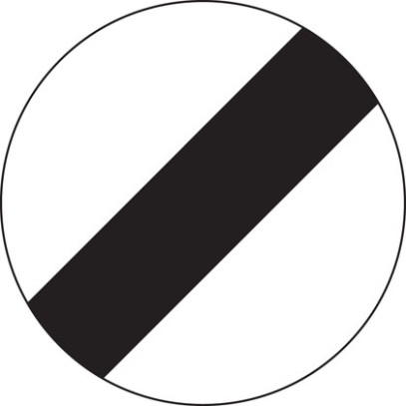 | [ ]National Speed Limit applies  [ ] No stopping  [ ] No Speeding
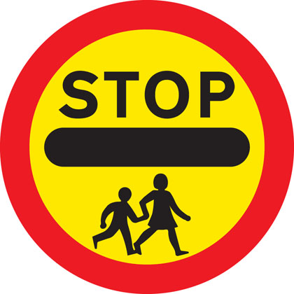 | [ ] No children beyond this point  [ ] School crossing ahead  [ ] Children must stop here
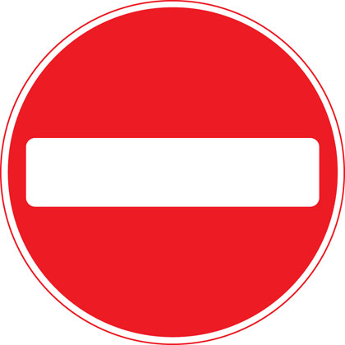 | [ ] No Entry  [ ] National Speed Limit applies  [ ] No speeding
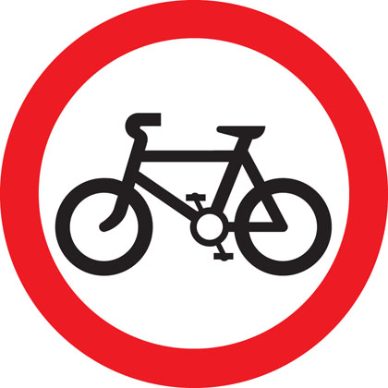 | [ ] No cycling  [ ] Cycles only beyond this point  [ ] Cycles must turn left ahead
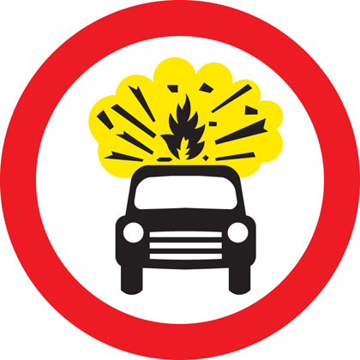 | [ ] Exploding vehicles up ahead – Danger!  [ ] No vehicles carrying explosives  [ ] Vehicles carrying fireworks up ahead – Beware!
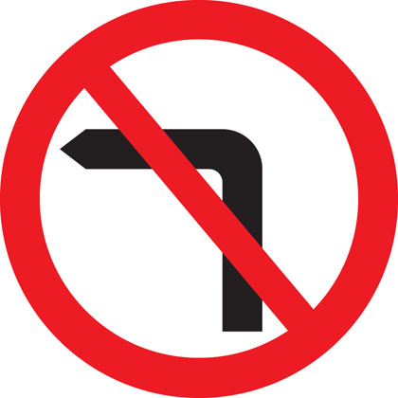 | [ ] Left turn only  [ ] Do not go this way  [ ] No left turn
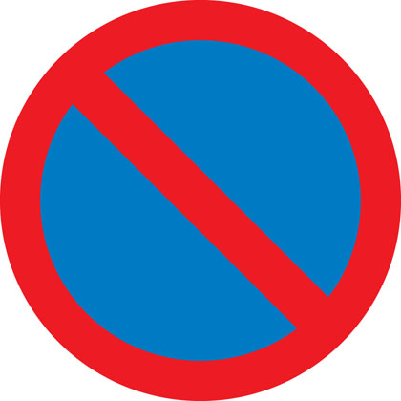 | [ ] No Stopping  [ ] No waiting.  [ ] No Driving
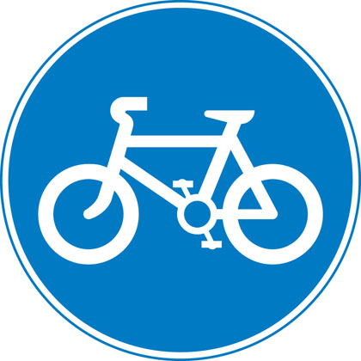 | [ ] Route to be used by pedal cycles only  [ ] One way street – cycles only  [ ] No cycles
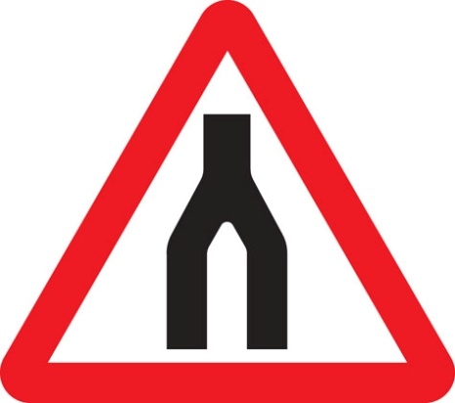 | [ ] Beware, headless men ahead!  [ ] Dual Carriageway Ends  [ ] Road narrows ahead
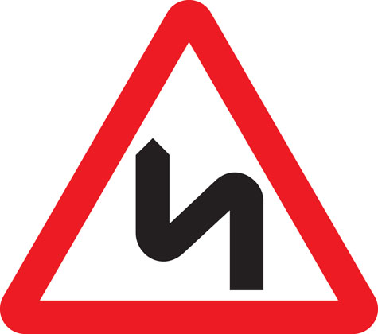 | [ ] Beware! Dangerous Road  [ ] Icy road ahead  [ ] Double bend first to left (symbol may be reversed)
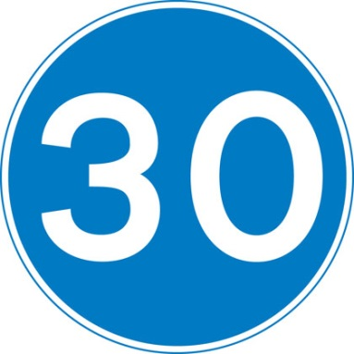 | [ ] Maximum Speed limit  [ ] Minimum Speed Limit  [ ]Maximum vehicle weight (In grams)
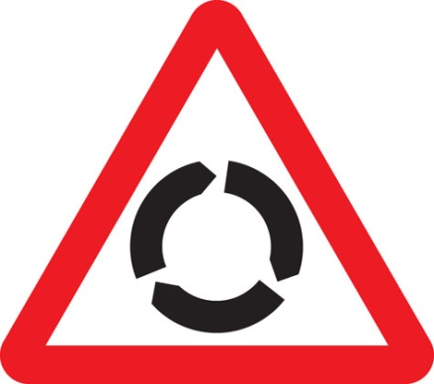 | [ ] Please check your steering wheel  [ ] Free way ahead  [ ] Roundabout ahead
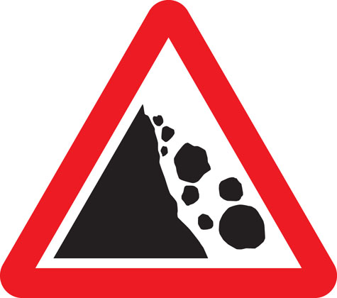 | [ ] Falling or fallen rocks  [ ] The Rolling Stones  [ ] Steep hills
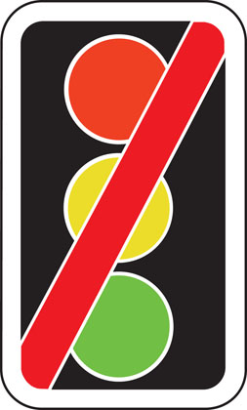 | [ ] Ignore the Traffic Lights ahead  [ ]Traffic signals not in use  [ ] Traffic signals ahead
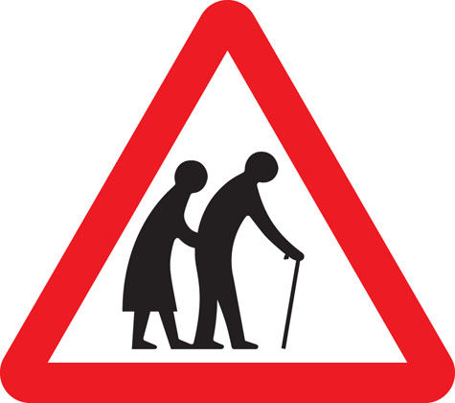 | [ ]Frail (or blind or disabled if shown) pedestrians likely to cross road ahead  [ ] Beware of old people  [ ] People using walking sticks only beyond this point
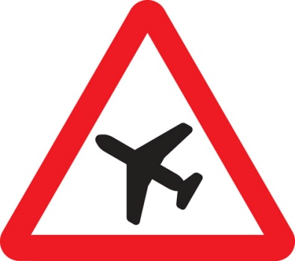 | [ ] Low-flying aircraft or sudden aircraft noise  [ ] Airport ahead  [ ] Aircraft only beyond this point
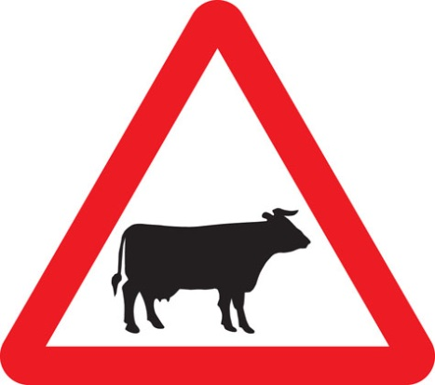 | [ ] Cattle only  [ ] Beware of cattle  [ ] Vehicle with cattle only ahead
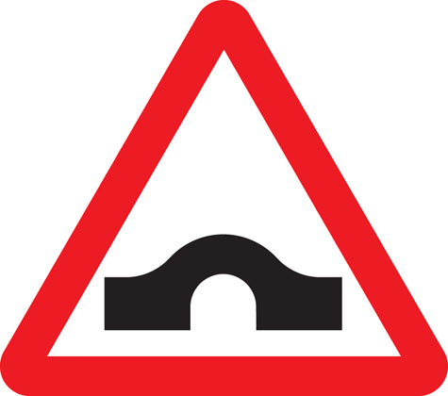 | [ ] Tunnel ahead  [ ] Railway ahead  [ ] Hump Bridge ahead
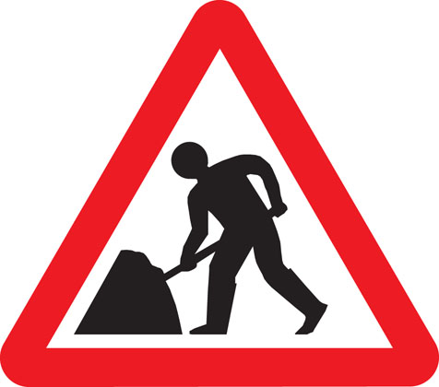 | [ ] Road works ahead  [ ] Men having trouble with umbrellas ahead  [ ] Please lower your umbrella when going through the tunnel
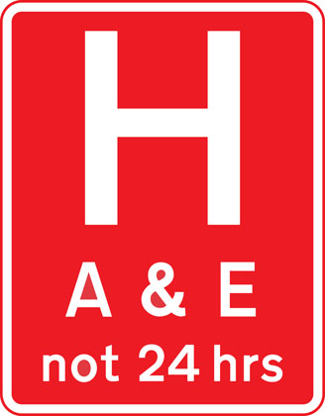 | [ ] Helicopter landing place ahead  [ ] Please check your eye sight here  [ ] Hospital ahead
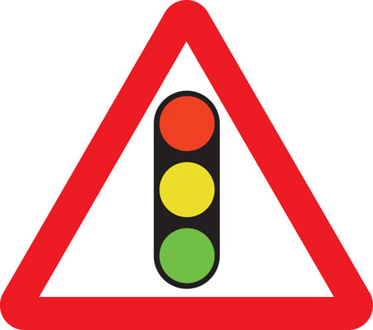 | [ ] Ignore the Traffic Signals ahead  [ ] Traffic signals ahead  [ ] Traffic signals ahead are not in use
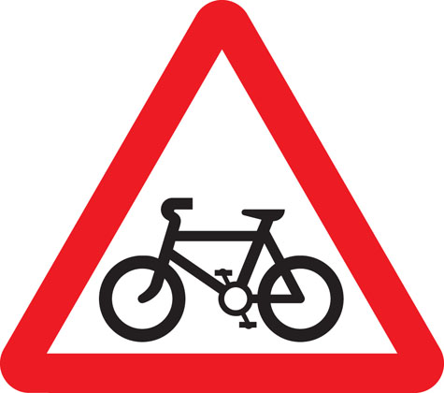 | [ ] No Cycles  [ ] Cars only  [ ] Cycle route ahead
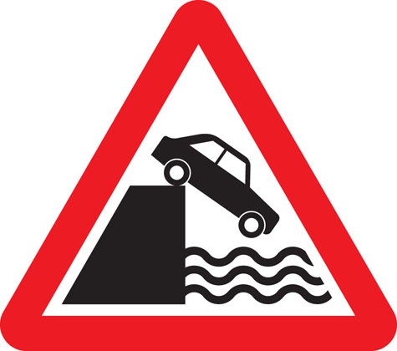 | [ ]Whoops! Be careful  [ ]Quayside or river bank  [ ] It’s the end of the road ahead!
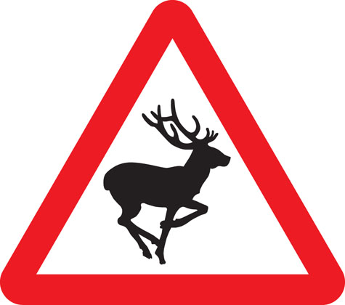 | [ ] No animals beyond this point  [ ] Oh Dear!  [ ] Beware, wild animals ahead

